Hospital Management System

1. **Creating the tables.**

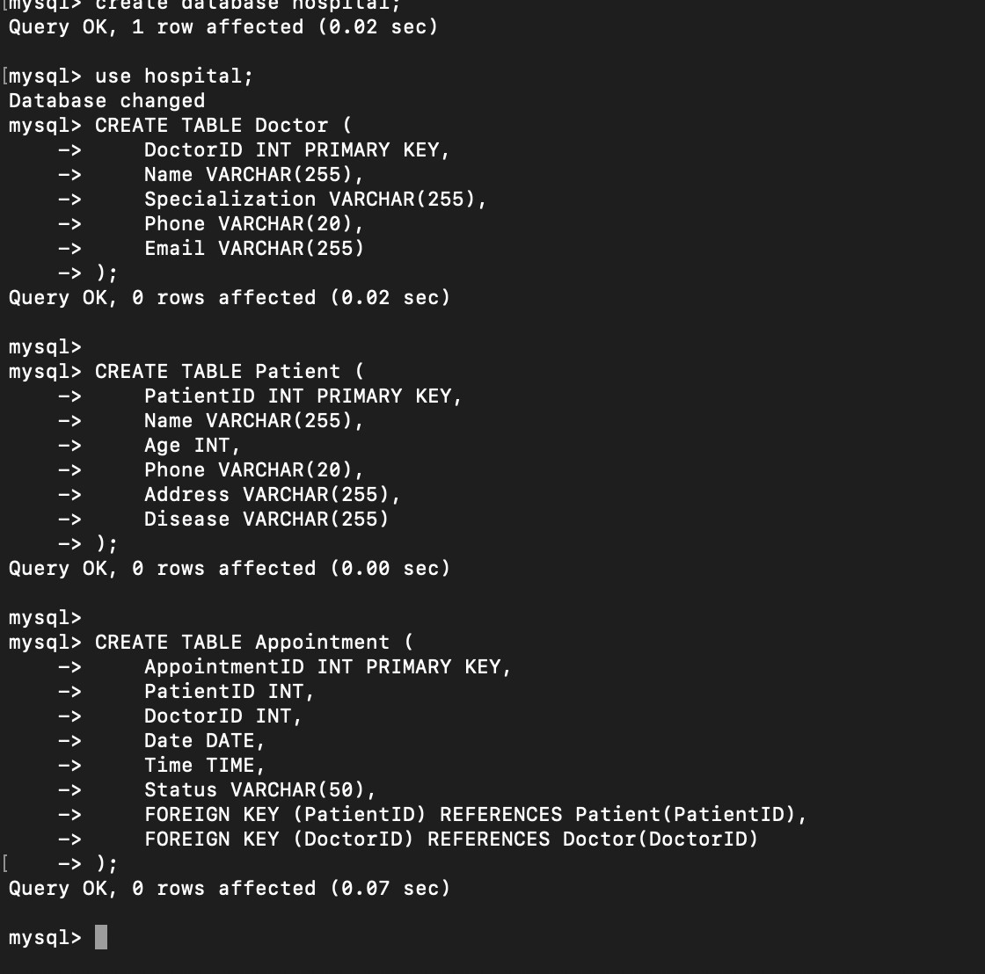

1. **Inserting sample data.**

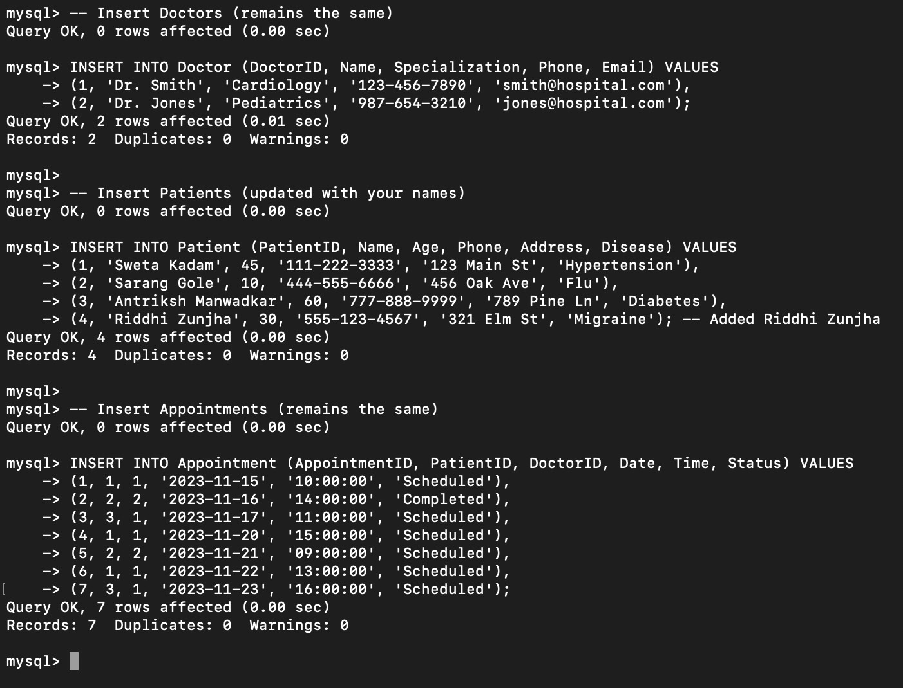

1. **Retrieve a list of patients assigned to "Dr. Smith".**

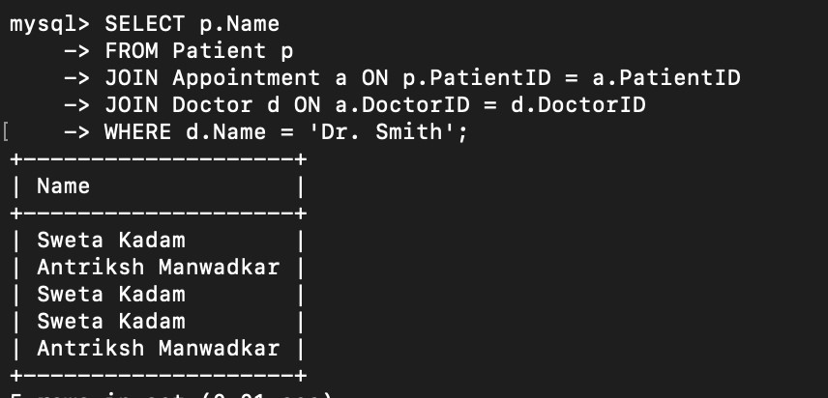

1. **Find doctors who have more than 5 appointments.**

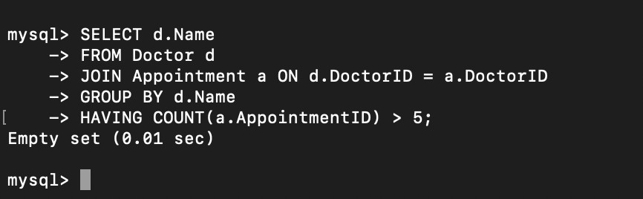

1. **Display the number of appointments each doctor has.**

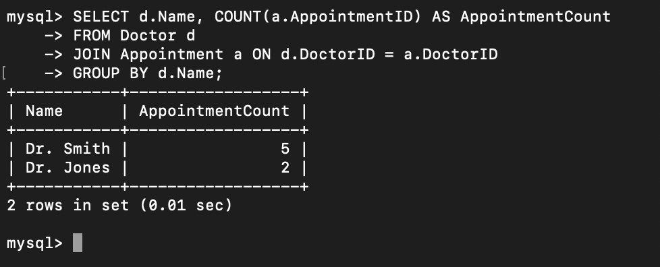

1. **Retrieve doctors who have no scheduled appointments.**

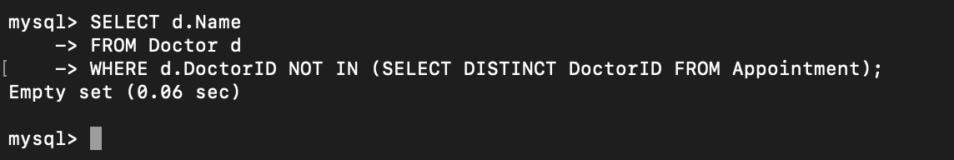

1. **Find the most common disease among patients.**

